Test contract document

# Chapter 1.

# Left Munich at 8:35 P. M., on 1st May, arriving at Vienna early next morning; should have arrived at 6:46, but train was an hour late. Buda-Pesth seems a wonderful place, from the glimpse which I got of it from the train and the little I could walk through the streets.

# Chapter 2. Image.

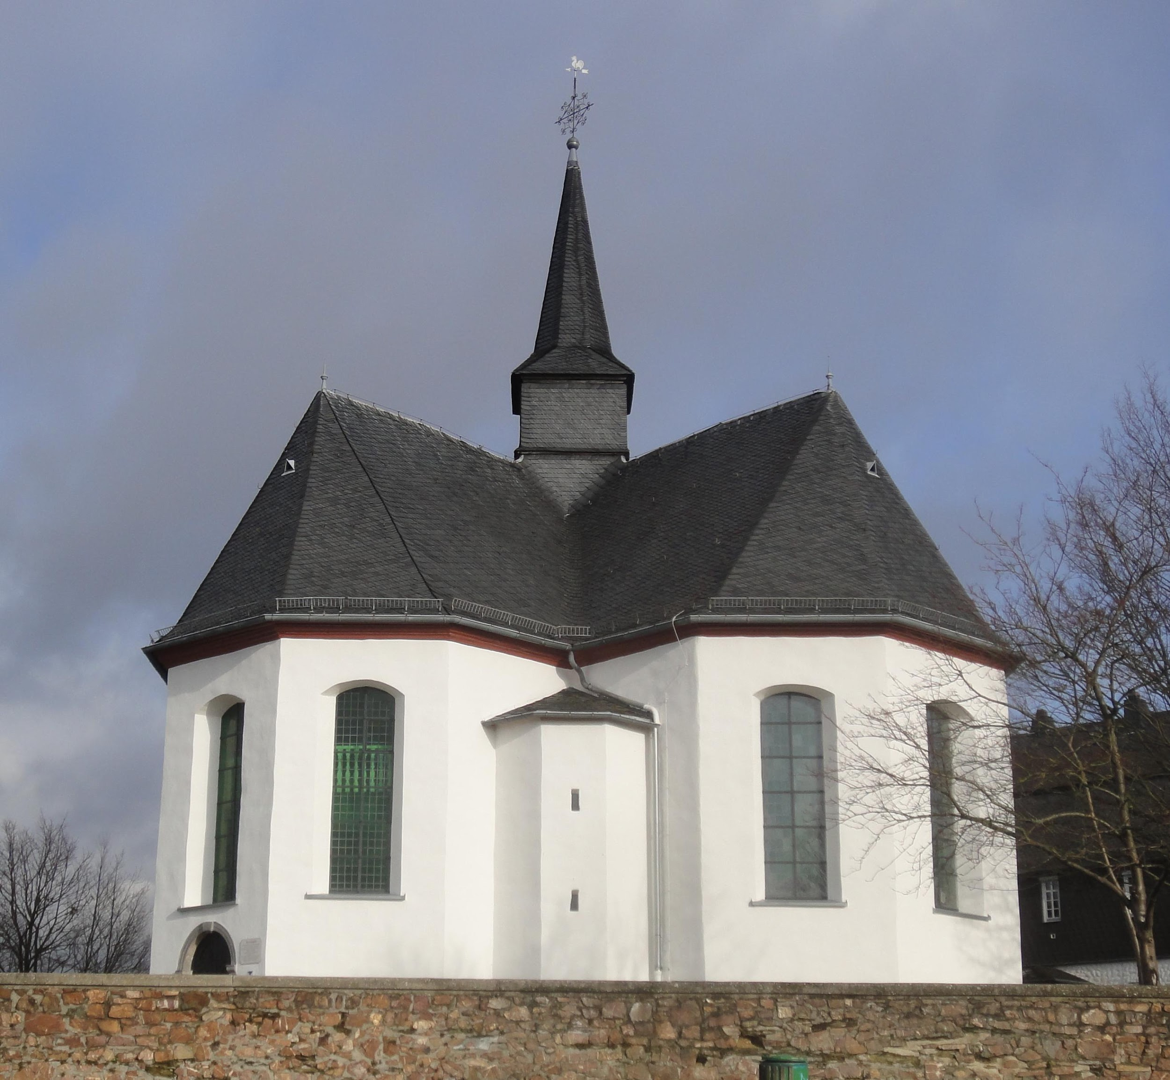

We left in pretty good time, and came after nightfall to Klausenburgh. Here I stopped for the night at the Hotel Royale. I had for dinner, or rather supper, a chicken done up some way with red pepper, which was very good but thirsty. (*Mem.*, get recipe for Mina.)